Michael Johnson
Newcastle University

De Stijl (1917-1932)

De Stijl (The Style) was an avant-garde artistic group founded in the Netherlands in 1917. The name was also applied to a journal used to propagate the group’s theories and published between 1917 and 1932. Led by the painters THEO VAN DOESBURG and PIET MONDRIAN, the group developed an abstract, elemental style based upon primary colours, geometric planes and right angles. Pursuing spiritual harmony based upon mathematical order, De Stijl formulated a universal language of pure form and colour. This became paradigmatic of Modernist visual art and design.

In 1915 the painter and theorist Theo van Doesburg encountered the work of Piet Mondrian, who had developed a visual style consisting of primary colours and asymmetrical, orthogonal grids. Mondrian was inspired by the mystical ideas of the Theosophists, particularly the eccentric mathematician M.H.J. Schoenmaekers, who devised a Neo-Platonic philosophy based upon pure geometric form. Influenced by Schoenmaekers’s publications The New Image of the World (1915) and Principles of Plastic Mathematics (1916), Mondrian developed an artistic philosophy known as Neo-Plasticism (Nieuwe Beelding):

This new plastic idea will ignore the particulars of appearance, that is to say, natural form and colour. On the contrary, it should find its expression in the abstraction of form and colour, that is to say, in the straight line and the clearly defined primary colour . . . [This art allows] only primary colours and non-colours, only squares and rectangles, only straight and horizontal or vertical line.

De Stijl was inherently Modernist because it aimed to achieve pure abstraction and simplicity by reducing all elements down to their essential form. In doing do, its proponents aimed to discover universal laws of spiritual harmony in both art and life.

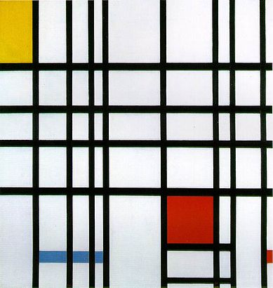

Piet Mondrian, Composition with Yellow, Blue, and Red, 1937–42, Tate Gallery, London

http://upload.wikimedia.org/wikipedia/en/7/72/Mondrian_CompRYB.jpg
In 1917, van Doesburg and Mondrian founded a journal called De Stijl and used it to promote the new aesthetic. Van Doesburg edited the journal from its inception until his death in 1931. A loose coalition of artists, designers, poets and thinkers formed around the eponymous journal and used it as a forum for their ideas. These included the architect J.J.P. OUD, the Hungarian artist Vilmos Huszàr (1884-1960), the Belgian sculptor Georges Vantongerloo (1886-1965) and the poet Antony Kok (1882-1969). The designer and architect GERRIT RIETVELD joined the group in 1919 and extended the style to three-dimensional objects and spaces. His experimental Red-Blue Chair (1918) can be interpreted as a three-dimensional version of a Mondrian painting. The intersection of planes and lines emphasised rather than impeded the surrounding space, and the ends of each strut were painted yellow to convey a sense of vectors shooting off into infinity.

De Stijl produced relatively few architectural structures, but Rietveld designed the Schröder House in Utrecht (1924), which remains the most complete expression of De Stijl principles. The house is an ensemble of interlocking planes and lines held in balance. The interior spaces have been reduced down to their underlying geometry in order to discover their essential form. The abiding impression is that Mondrian’s two-dimensional images have been extrapolated to three dimensions, thus creating an all-encompassing environment.

Proponents of De Stijl were motivated by a Utopian impulse to remodel the built environment according to universal laws of geometry, thereby elevating humanity to a higher intellectual and spiritual plane. To this end, Van Doesburg was determined to purify architecture and the applied arts. He designed colour schemes, stained glass and tiled floors for a number of architectural collaborations. In a departure from strict horizontal and vertical axes, his ambitious scheme for the Café de l’Aubette in Strasbourg used diagonals to create an effect of dynamic tension, an innovation which alienated Mondrian and prompted his departure from the group.

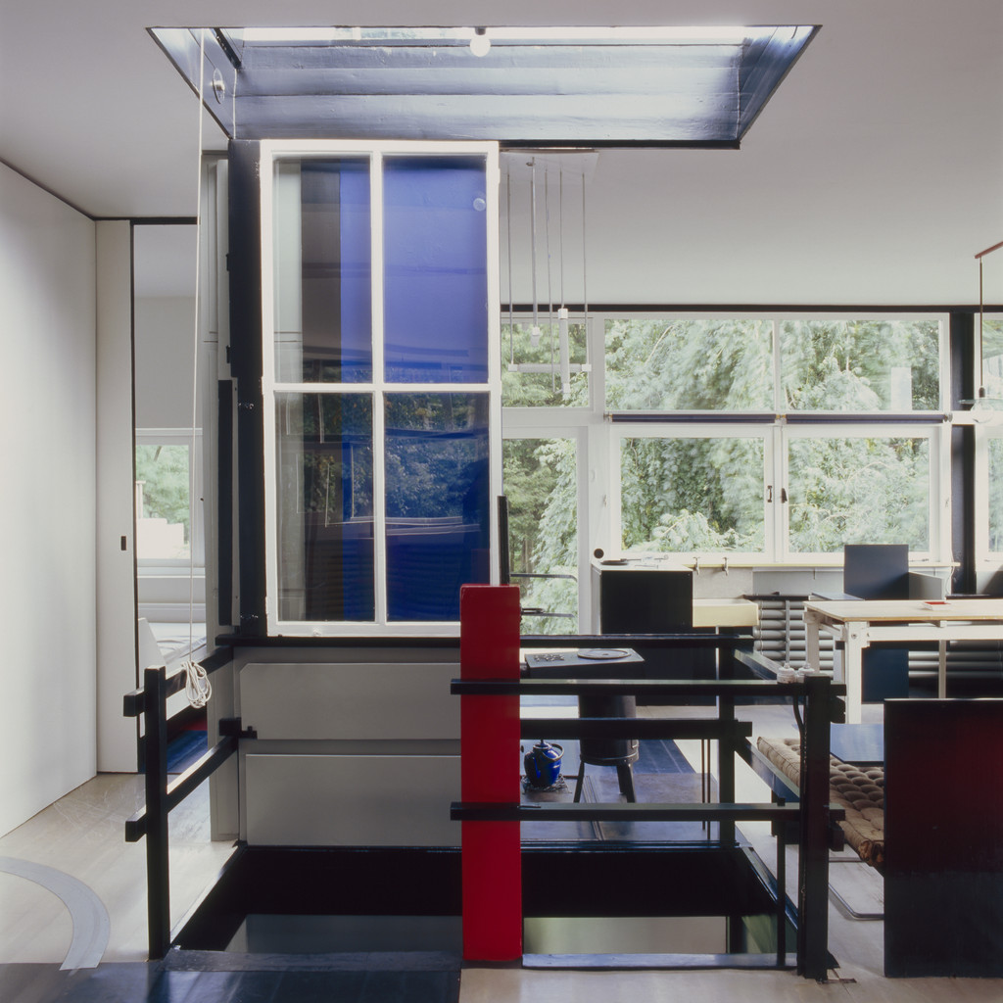

Interior of Gerrit Rietveld’s Schröder House, Utrecht, Netherlands, 1924.

http://www.design-museum.de/en/exhibitions/current-exhibitions.html

De Stijl was profoundly influential within avant-garde circles. Van Doesburg taught intermittently at the BAUHAUS, which was founded two years after the De Stijl movement, and encouraged Bauhaus designers to abandon their early Expressionist aesthetic in favour of pure geometric simplicity. The group began to dissipate in the late 1920s and finally came to an end with van Doesburg’s premature death in 1931. A final edition of De Stijl was published by van Doesburg’s widow the following year. Despite its abrupt demise, De Stijl exerted a long-lasting influence on Modernist architects such as LE CORBUSIER and LUDWIG MIES VAN DER ROHE.

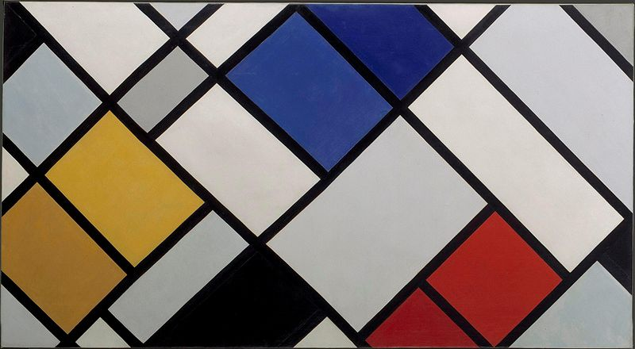

Theo van Doesburg Contra Composition XVI

http://triangleshirt.blogspot.co.uk/2010/12/theo-van-doesburg.html

References and further reading

Baljeu, J. (1974) Theo van Doesburg. London: Studio Vista. (A comprehensive monograph that analyses van Doesburg’s role as the editor of De Stijl and includes translations of his key writings).

Blotkamp, C. (1986) De Stijl: the formative years: 1917-1922. Cambridge, Mass.: MIT Press. (A collection of nine essays that provide a pluralist view of De Stijl in the early phase).

Hoek, E., Blokhuis, M., Goovaerts, I. and Kamphuys, N. et al. (2000) Theo Van Doesburg: Oeuvre Catalogus. Centraal Museum. (A Dutch-language catalogue of van Doesburg’s work).

Jaffé, H. L. C. (1970) De Stijl: extracts from the magazine, London: Thames and Hudson. (Extracts from the magazine De Stijl; selected and edited by Hans L.C. Jaffé and translated into English).
Mondrian, P. (1993) The New Art, the New Life: The Collected Writings of Piet Mondrian. Cambridge, Mass.: Da Capo Press. (A comprehensive collection of Mondrian’s essays, letters, notes, and interviews).

Overy, P. (1991) De Stijl: Art, Architecture, Design, London: Thames & Hudson. (A concise and accessible study of the De Stijl movement).

Troy, N.J. (1983) The De Stijl Environment, Cambridge, Mass.: MIT Press. (This book explores the group's approach to exterior and interior spaces and to furniture).

White, M. (2003) De Stijl and Dutch Modernism. Manchester: Manchester University Press. (This was the first book to view the De Stijl movement within the context of Dutch Modernism, exploring debates concerning abstraction in painting and spatiality in architecture).

